Py-Spark:
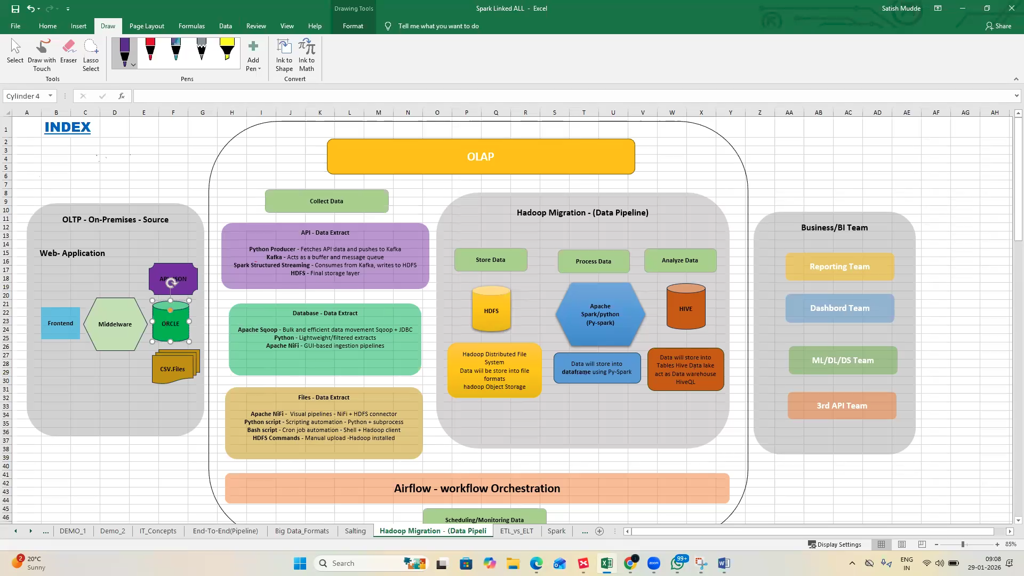

What is PySpark?
- PySpark = Python API for Apache Spark.
- Spark is a big data processing engine that can handle huge datasets across multiple machines.
- PySpark lets you write Spark code using Python instead of Scala/Java.

Simple Example: Word Count
Imagine you have a text file with sentences, and you want to count how many times each word appears.

Code:

from pyspark.sql import SparkSession

# 1. Start Spark
spark = SparkSession.builder.appName("SimpleExample").getOrCreate()

# 2. Load data (a text file)
text_file = spark.sparkContext.textFile("sample.txt")

# 3. Split each line into words
words = text_file.flatMap(lambda line: line.split(" "))

# 4. Map each word to (word, 1)
word_pairs = words.map(lambda word: (word, 1))

# 5. Reduce by key (sum counts)
word_counts = word_pairs.reduceByKey(lambda a, b: a + b)

# 6. Show results
for word, count in word_counts.collect():
print(word, count)

What Happens Step by Step
- SparkSession starts the engine.
- Load file into Spark.
- Split lines into words.
- Map each word to a pair (word, 1).
- Reduce by key → add up counts for each word.
- Collect results back to Python and print.

Output Example
If sample.txt contains:
hello world
hello spark

The result will be:
hello 2
world 1
spark 1

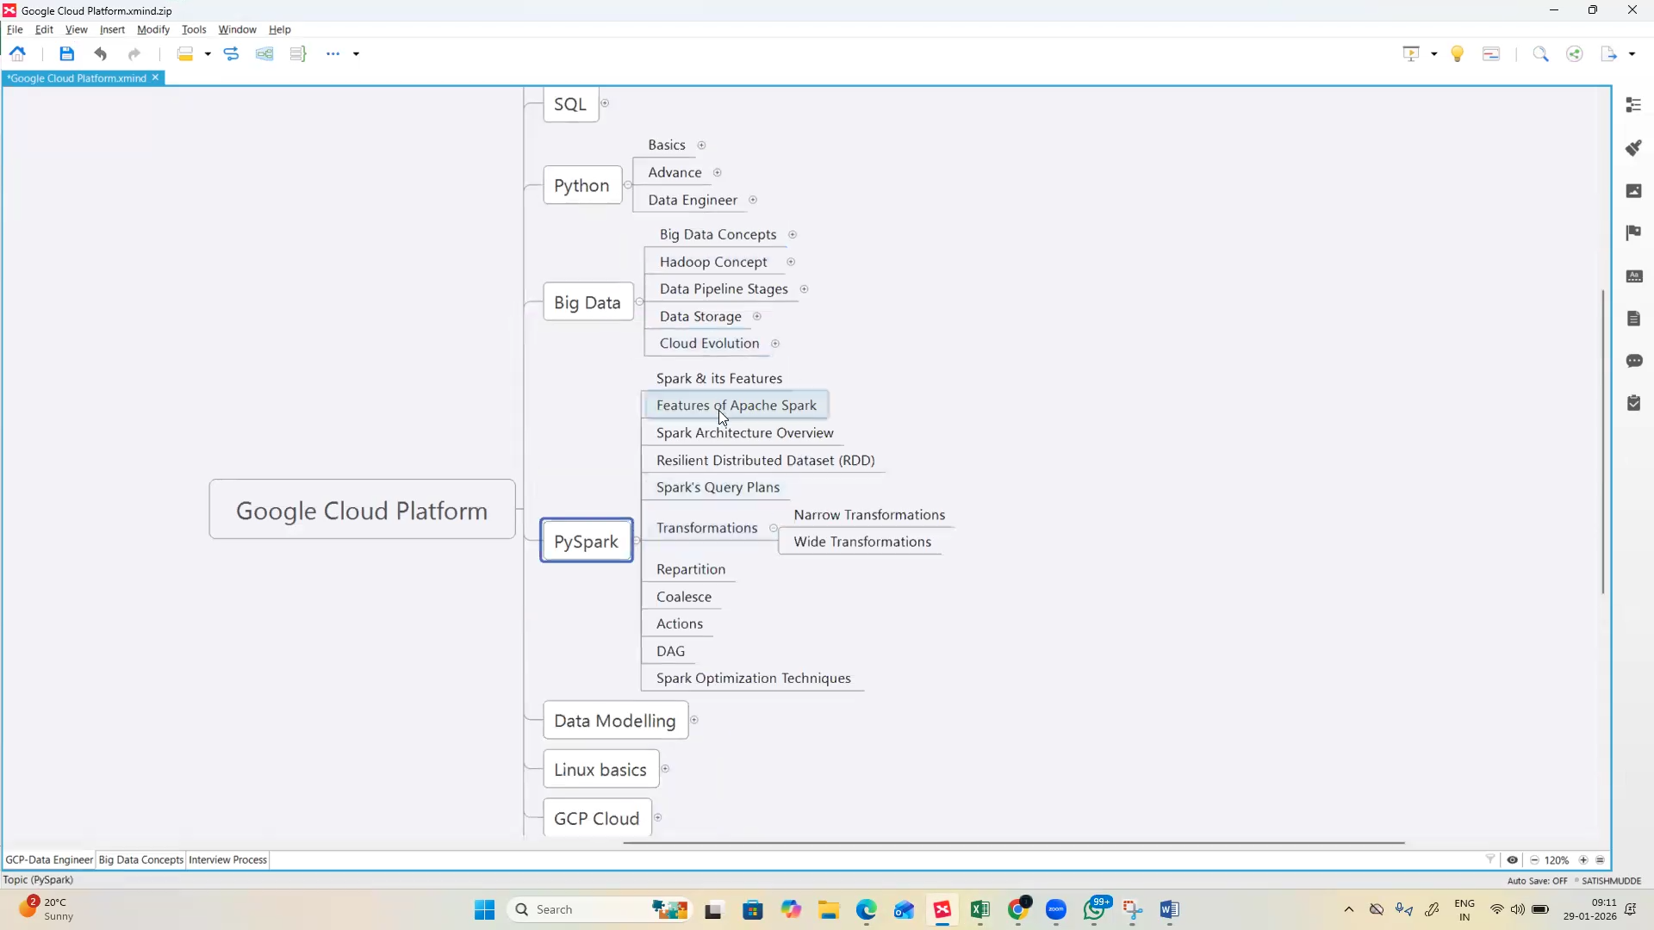
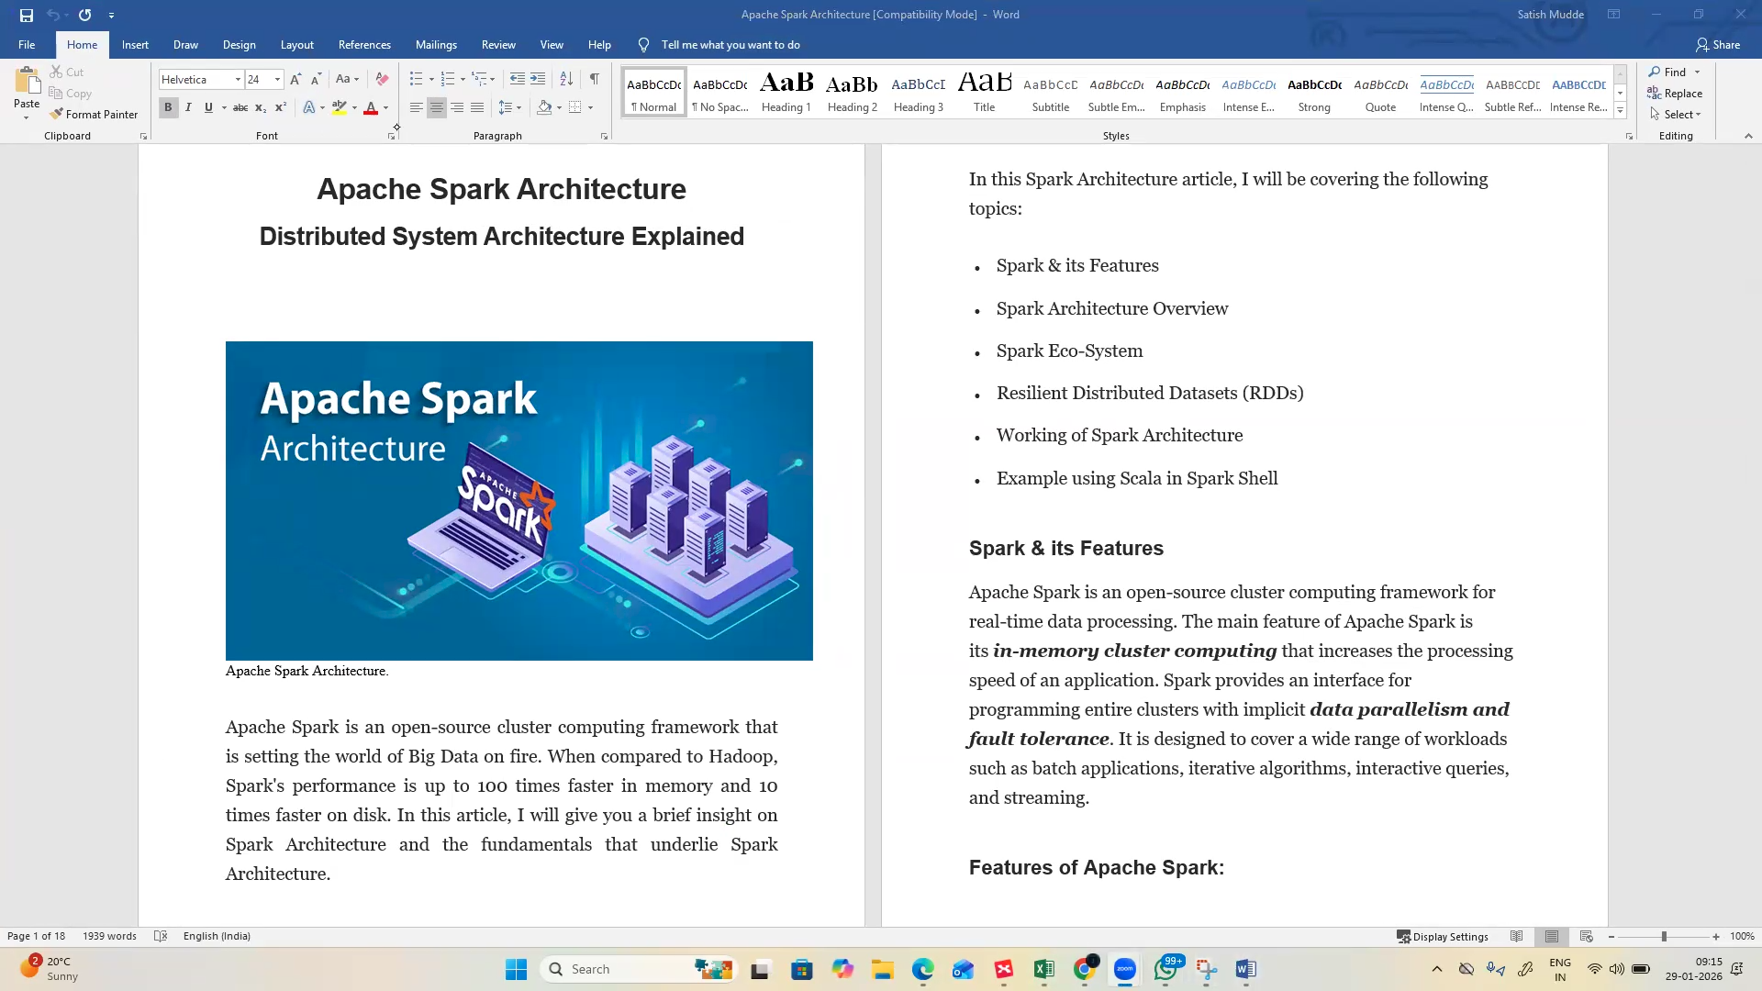

- Spark framework – architecture
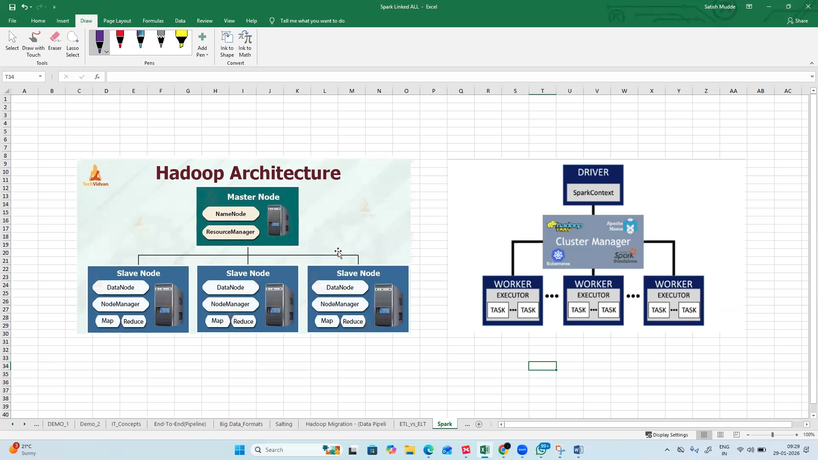

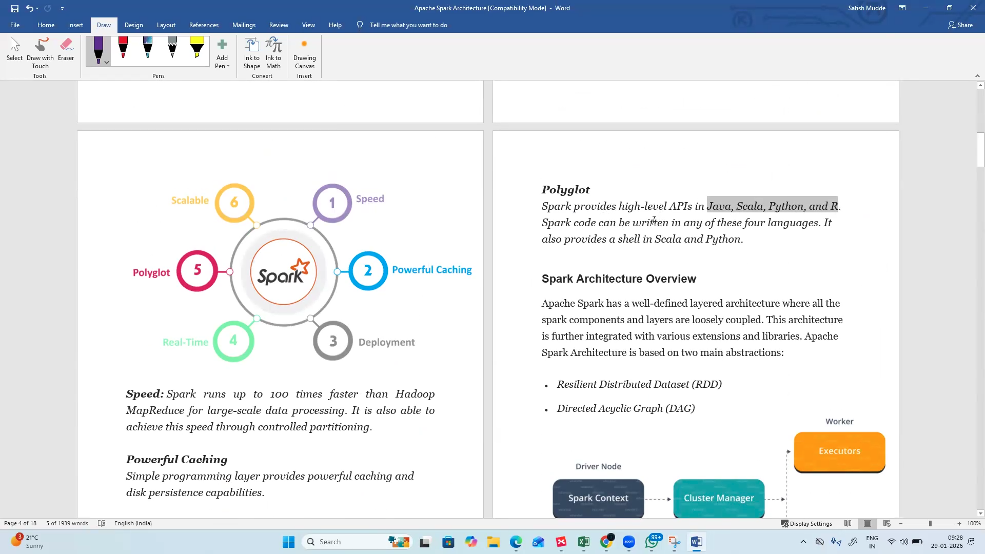

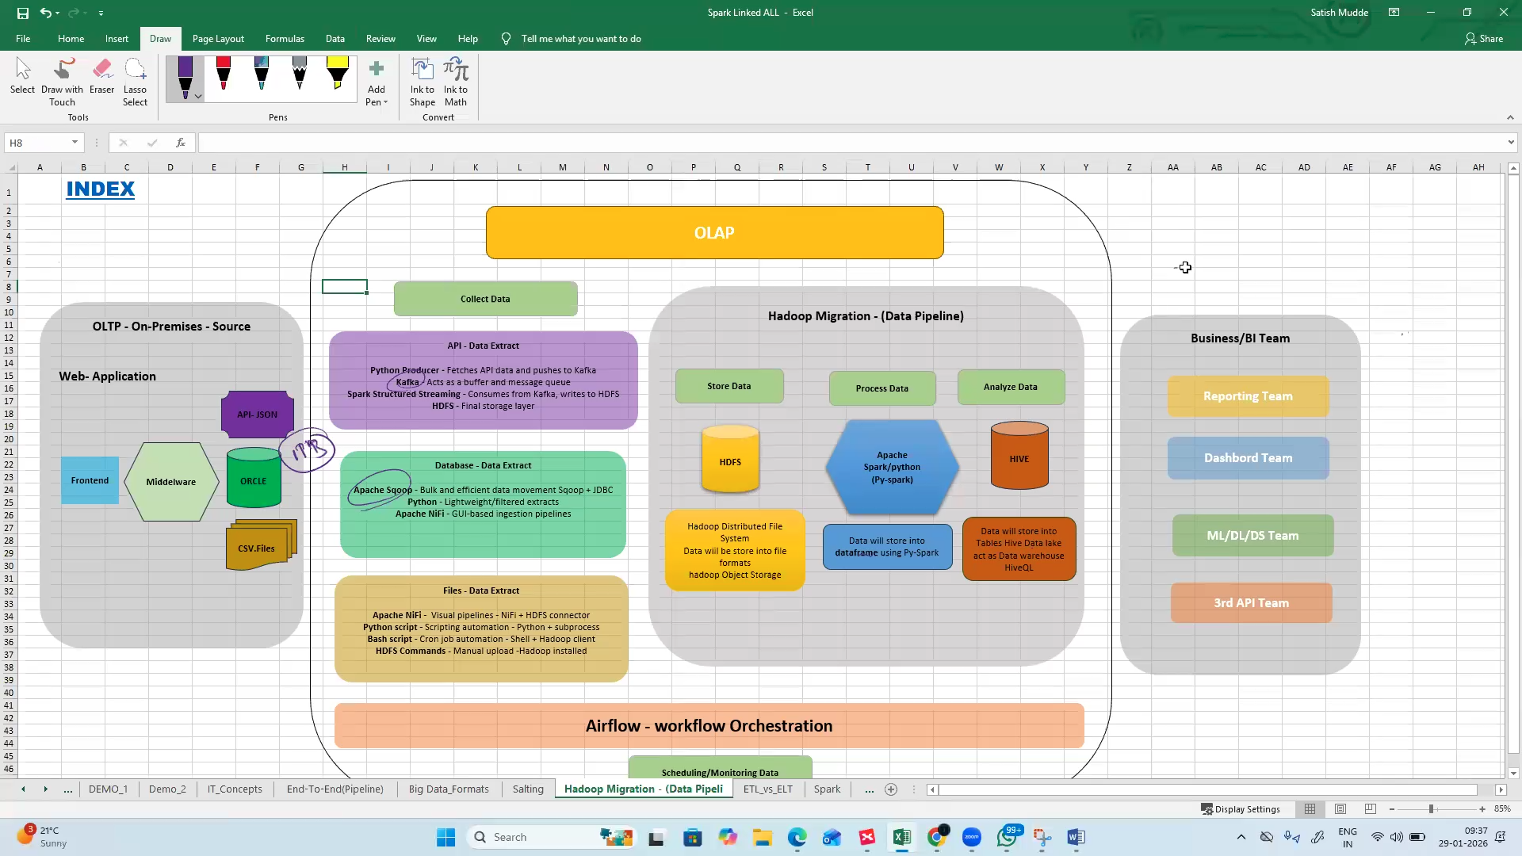
- Data frames are created to store data using Py-Spark

- Spark Memory Management:


